Dangerous Driving – Henry, Elizabeth College

Firstly we need to understand what the question is asking. What we need to figure out is whether his car, which can accelerate from rest to 96 kmh⁻¹, could have reached a speed of 133kmh⁻¹ having travelled 338m starting at rest. So what we need to discover is what the highest speed he could be going after 338m is.

The first step is to convert kmh⁻¹ into ms⁻¹; this allows us to work with the numbers more easily.

we know that
so
therefore

Knowing this we can figure out the car’s acceleration in ms⁻².
The car can accelerate from 0 to 96kmh⁻¹ in 10.5 seconds.
Knowing that
We can multiply both sides by 96 giving
We now know that the car accelerates from rest to 80/3 ms⁻¹ in 10.5 seconds.
We can calculate the acceleration by dividing the increase in speed by the time taken to give us increase per second (acceleration).

Now that we know the car’s acceleration in ms⁻² we have to work out whether or not it could reach a speed of 133kmh⁻¹ over 338 metres.

There is a mechanical formula
where v is final velocity, u is starting velocity, a is acceleration and s is distance moved.
If we substitute in these figures from our scenario we get:
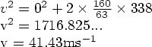
Now we need to convert this back into kmh⁻¹
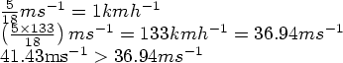
therefore he could have been going as fast as the camera recorded and the case should not be dismissed on mathematical grounds.

